**Experiment No: 16**

**Name of the Experiment:** Study of Euler’s Method to Solve Ordinary Differential Equation(s) (Initial Value Problem)

**Objectives:** The objective of this experiment is to use to Solve Ordinary Differential Equation(s) with Initial Value, using MATLAB.

**Theory:** This method uses the simplest extrapolation techniques for developing a solution. Equations (9.1) and (9.2) are written below for ready reference.

$$\frac{dy}{dx}=f(x, y)$$ (1)

**𝑦 = 𝑦1 𝑎𝑡 𝑥 = 𝑥1** (2)

Given (𝑥1, 𝑦1) the slope at this point is obtained as

$$\frac{dy}{dx}\left(x1,y1\right)=f\left(x1,y1\right)$$**(**3)

The next point 𝑦2 on the solution curve may be extrapolated by taking a small step in a direction given by the above slope. Thus

$y(x1 + h) = y2 = y1 + hf(x1, y1 )$ (4)

**Tool:** MATLAB Software

**Methodology:**

**Problem:** The temperature radiation of a ball in air at ambient temperature 300K can be describe by the differential equation

$\frac{d∅}{dx}$ = −𝟐. 𝟐𝟎𝟔𝟕 × 𝟏𝟎-𝟏𝟐(∅𝟒 − 𝟖𝟏 × 𝟏𝟎𝟖)

Using Euler’s method find the temperature of the ball at 𝒕 = 𝟒𝟖𝟎 seconds where ∅ is in K and t in second. It is assumed that the initial temperature of the ball is 1200K.

**MATLAB Code:**

clear all;

close all;

clc;

f=@(x,y)-2.2067*10^-12*(y^4-81*10^8);

h=60;

n=7;

y0=1200;

x0=0;

xi=x0;

yi=y0;

for i=0:n

yi=yi+h*f(xi,yi);

xi=xi+60;

end

xi

yi

**Output:**

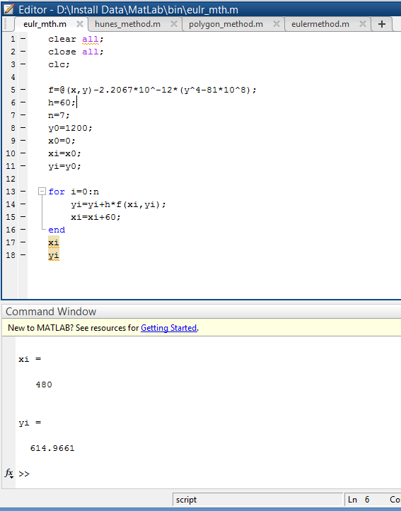

**Result(s)& Discussion:** The result is ∅(480) = ∅8= 614.9661409K

**Conclusion:** the result is not the exact value as we find from polygon method. There are some error.

**References:**

[1] PDF given by **Prof. Dr. Md. Shamim Anower**